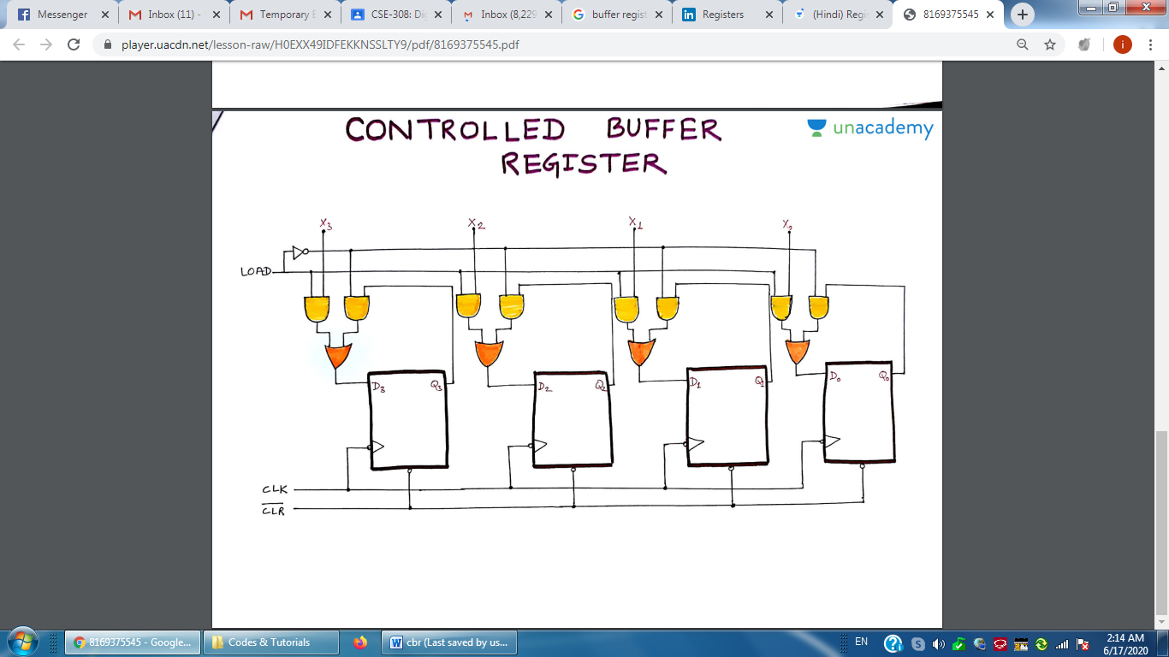
A 4-bit Controlled Buffer Register

module cbr (CK, DIN, Q, LD, CLR);

input CK, LD, CLR;
input [7:0] DIN;
output [7:0] Q;

reg [7:0] Q;

always @(negedge CK)
if (~CLR)
Q = 8'h00;
else
if (LD)
Q = DIN;

endmodule

module test_cbr;

reg CK, LD, CLR;
reg [7:0] DIN;
wire [7:0] Q;

cbr r1 (CK, DIN, Q, LD, CLR);

always
#3 CK = ~CK;

initial
begin
CK = 0;
DIN = 8'b10101010;
#20 DIN = 8'hFF;
#5 DIN = 8'hAB;

end
initial
begin
LD = 0;
CLR = 0;
#10 LD = 1;
#5 CLR = 1;
#12 LD = 0;

end

endmodule

